*You dont need to position your channel yet. Keep watching the videos. It'll be very clear when to make this decision.
How To Position Your Channel: The Umbrella
Think of your channel like an umbrella:
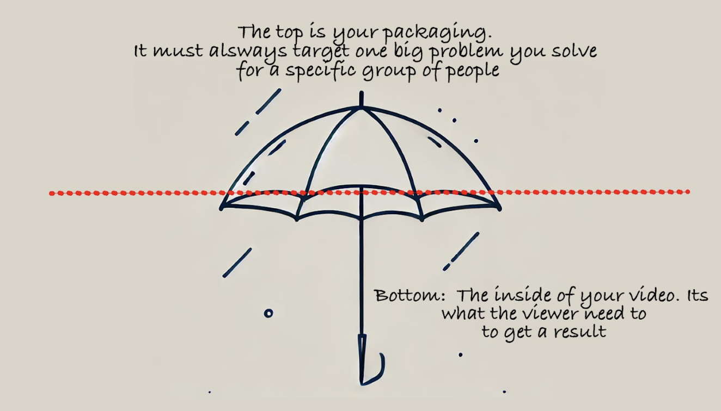
1. The Top of the Umbrella
- The big problem or result your viewers care about and know they have.
- This is what your video’s thumbnails and titles target.
- You need to come up with one statement that says “I help [SPECIFIC PERSON] get [BIG RESULT]
Examples:
- I help garden lovers grow vegetables faster
- I help men land more dates using apps
- I help women grow Etsy stores
2. The Bottom of the Umbrella
- The specific topics you can talk about within your videos.
- These are the things viewers need but might not know they need.
3. How To Position Your Channel: Step by step guide
Step 1: Identify Your Target Audience and Their Big Problem
Ask yourself:
- Who do I want to help?
  - Be specific: “software developers,” “beginners in SaaS,” “people over 60.”
- What is their BIG problem or desire?
  - “They want to grow vegetables at home.”
  - “They want to start a business and quit their job.”
This is the top of your umbrella.
🚨 The avatar + research videos will help you work this out. You don't have to commit to anything until after the research.
TASK: Write a draft umbrella statement “I help X get Y” (Just take an educated guess right now, we will build on this)
Step 2: Find Out What Viewers Actually Care About
- Study other channels:
  - What problems are their most-viewed videos solving?
  - What titles and thumbnails resonate most with their audience?
  - The pattern spotting videos will teach you how to do this
- Look for underserved areas in your niche.
  - Example: BGO avoided competition in the broad “business” niche by focusing on software developers starting businesses.
  - Its not always possible to find this, but we want to keep it in mind.
Step 4: Differentiate Yourself from the Competition
To stand out in a crowded niche:
- Position your channel to serve a specific audience with a specific problem.
- Example: Shrey’s channel grew to 100k subscribers in 9 weeks by focusing on helping people over 60 become more mobile.
✅ Checklist for Differentiation:
- Are you solving a specific problem?
- Are you targeting a group no one else is targeting?
- Are you delivering a unique perspective or method?
- Are you credible in solving this problem?
Step 5: Refine and Adjust Your Positioning Over Time (Ready, fire aim)
You won’t position your channel perfectly from day one. It's a game of starting out with a research and then reacting to what happens when you post your videos.
- Some videos will perform better, so you figure out why, and do more of that. (The measurement modules will help with this)
- Some videos will perform worse, so you figure out why, and do more of that. (The measurement modules will help with this)
The basics of this with regards to packaging are, If a video underperforms:
Ask why viewers might not have clicked:
- Does the title assume too much knowledge?
- Is the thumbnail confusing or unclear?
- Is the topic not of interest ?
- Was the video idea not validated by outliers?
5. Positioning Checklist for Every Video
Before releasing a video, ask:
- ✅ Does the title and thumbnail target the big problem I want my channel to become known for?
- ✅ Will my target audience instantly know this is for them?
- ✅ Does this video align with the umbrella top?
- ✅ Am I solving a problem or delivering a result my audience knows they have and care about?

